Pro File Viewer – Metadata Scanner Tool

Final Year Project Report

Muhammad Maaz (BSE-21F-094)
Fahad Ahmed (BSE-21F-090)
Muhammad Siddiqui (BSE-21F-098)

SESSION 2021-2025



Supervisor/Co-Supervisor

Mr. Zubair Uddin Shaikh

Project report in partial fulfillment of the requirements for the award of Bachelors of science (software engineering) degree.
IN

DEPARTMENT OF SOFTWARE ENGINEERING

SINDH MADARESSATUL ISLAM UNIVERSITY KARACHI, PAKISTAN

(August 2025)

STUDENT’S DECLARATION
We declare that this project entitled Pro File Viewer – Metadata Scanner Tool, submitted as requirement for the award of BS (SE) degree, does not contain any material previously submitted for a degree in any university; and that to the best of our knowledge it does not contain any materials previously published or written by another person except where due reference is made in the text.

Team Lead Name: Fahad Ahmed Signature:

Member 1 Name: Muhammad Maaz Signature:

Member 2 Name: Muhammad Siddiqui Signature:

Supervisor Name: Mr. Zubair Uddin Shaikh Signature:

CERTIFICATION OF APPROVAL
The Department of Software Engineering, Sindh Madrassatul Islam University, accepts this thesis submitted by Muhammad Maaz, Fahad Ahmed and Muhammad Siddiqui in its present form and it is satisfying the dissertation requirements for the award of Bachelor Degree in Software Engineering.
Dated:

Supervisor  Supervisor Name: Mr. Zubair Uddin Shaikh | Signature:
Dean / HOD of Department  Dean / HOD Name: Dr. Abdul Hafeez | Signature:

Department Of Software Engineering Sindh Madrassatul Islam University, Karachi, Pakistan

ACKNOWLEDGMENT
First and foremost, we are grateful to the almighty ALLAH S.W.T for allowing us to complete our Final Year Project and for providing us with the strength we required to perform our responsibilities as Software Engineering students.

Now, we would like to express our gratitude to everyone who helped us complete this project successfully. We would like to express our gratitude to Mr. Zubair Uddin Shaikh, our project supervisor, and co-supervisors, for their essential counsel, direction, and immense patience during the development process.

Furthermore, we would want to express our gratitude to our loving guardians and companions who have assisted and encouraged us.

DEDICATION
This project report which title is Pro File Viewer - Metadata Scanner Tool by Muhammad Maaz (BSE-21F-094),Fahad Ahmed (BSE-21F-090) and Muhammad Siddiqui (BSE-21F-098) is submitted to Sindh Madrassatul Islam University, our Teacher, our Supervisor, our Parents, our fellow colleagues and the hard-working students of SMIU, with a hope that they will succeed in every aspect of their Academic Career and this project may help them in any aspect of their life.

ABSTRACT

Every file saved on a computer contains important hidden information about it, such as name, size, type, date of creation, last modification date and who can access it .This hidden information is known as metadata. Metadata helps in understanding the background and history of the file. However, when there are hundreds or thousands of files stored in different folders, checking the metadata of each file manually becomes a very slow and difficult task. Most available tools for this purpose are either too complex to use or require technical knowledge. To solve this problem, we developed Pro File Viewer simple and user-friendly desktop tool built using Python. This tool allows the users to select any folder, they automatically scans all files inside it, collect their metadata and display everything neatly in a table format within the tool.

Pro File Viewer designed to be a useful for everyone, whether they are technical or non-technical users. It also provides filter options to help users find specific files. Users can filter files based on file size, file type, and the date when the file last modified. Once the desired results shown users can export the filtered metadata into a CSV file, which can easily opened in Microsoft Excel or Google Sheets. This makes it simple to prepare reports or save the data for later use. Pro File Viewer is completely safe to use as it only reads the file information and does not modify or delete any files. It is especially helpful for students, teachers, IT professionals and anyone who needs to manage or analyze large sets of files. Pro File Viewer makes the process of viewing and managing file details faster, easier and more reliable.

Table of Contents
STUDENT’S DECLARATION 2
CERTIFICATION OF APPROVAL 3
ACKNOWLEDGMENT 4
DEDICATION 5
ABSTRACT 6
CHAPTER 1 11
- INTRODUCTION 11
  - Overview 11
  - Contribution: 11
  - Motivation: 12
  - Problem Declaration: 12-13
  - Objectives: 13
    - Main Objective: 13
    - Functional Objective: 13
    - Non-Functional Objective: 14
    - Usability and Accessibility Objective: 14
  - Scope: 14
  - Modules: 14-15-16
  - Category of Project: 16
  - Deliverables: 17
  - Consequential Of The System: 17
  - What Did This System Can’t Do? 17
  - Feasibility Study: 17-18
  - Project Planning: 18
  - Gantt Chart 18
CHAPTER 2 19
- LITERATURE REVIEW 19
  - Introduction: 19
  - Review Of Existing Tools and Systems: 20
  - Sorting Algorithms In File System 20
  - Identified Research Gape 20
  - Contribution Of Pro File Viewer 20
CHAPTER 3 21
- METHODLOGY 21
  - Introduction: 21
  - Data Required And Controlled By The System: 21
    - Metadata As Primary Data Source: 21
    - Data Handling And Security: 21-22
    - Purpose Of Data Usage: 22
  - Solution Implementation Environment: 22
    - Programming Language And Framework: 22
    - File Handling And System Libraries: 22
    - Visualization And Export Features: 22
    - Development And Testing: 23
  - Functions Provided By The System: 23
  - Use Case Diagram: 23
CHAPTER 4 24
- REQUIREMENT SPECIFICATION AND DESIGN 24
  - Proposed System And Required Specification: 24
    - Proposed System: 24
    - Required Specification: 24
  - Logical Design: 25
    - Flowchart Diagram: 25
    - UML Diagram: 26
    - Data Flow Diagram: 27-28
  - Software Development Lifecycle: 28
    - Agile Model: 28
  - Interface/GUI: 29
    - System Layout: 29
    - Home Page Layout: 29
    - Category: 30
    - Top Four Different File Extensions: 31
    - Export To CSV Layout: 31
    - Filter Panel Layout: 32
    - Error Message Layout: 32
CHAPTER 5 33
- SYSTEM IMPLEMENTATION 33
  - Overview: 33
  - Algorithm Used: 33
    - Folder Scanning Algorithm: 33
    - Metadata Extraction Algorithm: 33
    - File Filtering Logic: 34
    - Pie Chart Generation: 34
    - Top Largest Files Algorithm: 34
    - CSV Export Logic: 34
  - Tool / Technology Used: 34-35-36
  - Code Section: 36
    - Import Libraries And Initialization: 36
    - Browse Folder Section: 36
    - Open Filter Window: 36
    - Show All Files And Metadata: 37
    - GUI Layout & Main Window: 38
CHAPTER 6 39
- TESTING AUTOMATION TESTING 39
  - Testing Tool: 39
    - Python Unittest Framework: 39
    - Manual Testing For GUI: 39
    - Simulated Folder Environment: 40
    - Tool Selection: 40
    - Additional Modules: 40
  - Testing Methods: 40-41
  - Test Cases: 42 till 52
CHAPTER 7 53
- CONCLUSION AND FUTURE WORK 53
  - Conclusion: 53
  - Future Work: 53
    - Multi-Folder Scanning: 54
    - Search And Filter Enhancement: 54
    - Report Generation Using Different Formats: 54
    - Cloud Storage Support: 54
    - Drag And Drop User Personalization: 54
- REFRENCES: 55

CHAPTER 1

INTRODUCTION

Overview:

In today’s digital world, a large amount of data is stored on personal computers, office systems and organizational servers. Each file in these systems carries not just the content but also important details about the file itself. These details include the file name, size, type, creation date, last modified time, access time and permissions. This information called file metadata. Metadata helps user and system understand when and how a file used and who can accessed it, and what type of data it’s contain. It is widely used in areas like system administration, backup management and file organization.

However, manually checking file metadata for hundreds of files spread across multiple folders is a time consuming and complex task, especially for non-technical users. Most tools available for metadata inspection are either command-line based or require advanced technical skills to operate. There is a need for a tool that is simple, easy to use and capable of automatically extracting and presenting file metadata in a structured and readable format.

To solve this problem, we developed Pro File Viewer, a desktop tool that helps users view, filter and export file metadata from selected folders. Pro File Viewer created using Python and features a simple graphical user interface (GUI) created with TKinter. It allows users to select a folder, scans all files inside it and display key metadata in a table format. Users can filter the results by file type, size or modification date and export the data to a CSV file for reporting. Pro File Viewer is especially helpful for students, teachers, IT professional and organizations that need to manage large file systems in a quick and easy way.

Contribution:

Pro File Viewer contributes a practical and user-friendly solution for extracting and analyzing file metadata from local folders. Instead of using command line tools or performing manual checks, this tool allow users to automatically scan folders and view detailed metadata in a structured table format. It supports recursive scanning, meaning it collects data from all subfolders as well.

The project add value by including smart filtering options that let users narrow down results based on file size, file type or last modification date. This improves both speed and accuracy when working with large set of files. Another key contribution is the ability to export filtered data into CSV file, which makes documentation and reporting easy. Designed with simplicity in mind, Pro File Viewer bridges the gap between technical functionality and everyday usability. It supports efficient file system analysis for a wide range of users including students, teachers and researchers.

Motivation:

Managing Large Number of Files

As digital data continues to grow, people store thousands of files on their computer like documents, PDFs, presentation and more. These files are usually saved in multiple folders and subfolders and making it hard to track what is stored and where. Each file includes hidden details called metadata (file name, type, size) which helps user to organize and review their data. However, there is no quick or simple way to view all metadata at once, especially when working with large folders containing many files.

Limitation in Existing Tools

Many existing tools can extract file metadata, but they are often complex, outdated or lack of basic feature. Some require users to write commands, while others do not allow filtering by file size and type. A few tools do not support exporting results and many do not show data in a clear table or visual format. These limitations make it hard for non-technical users. Even technical users find it frustrating to switch between different applications just to complete a simple task.

Identifying the Missing Features

We realized there was some missing features, user need a tool that can do everything in one place. It should scan folders and subfolders and extract metadata, show the data clearly, allow filtering and let users export the results. We also saw the need for visual features like pie charts and file previews to help users quickly understand what type of files they have. Our goal was to make something simple, clean and helpful for all types of users.

Introducing Pro File Viewer

To solve the problem of accessing and managing file metadata easily, we developed Pro File Viewer, a desktop base application built with Python. The tool offers a clean and user-friendly interface that allows users to select any folder, scan all files (including subfolders) and view important metadata like file name, size and type in a simple table format. This tool also includes smart filtering options to narrow down files by type, size or date making it easier to work with large data sets. It display summary statistics such as total file count and total size, and including a pie chart to visually represent file types. A preview section highlight the top five largest files to help users quickly identify heavy files. One of its key feature is the ability to export filtered result to a CSV file, which is useful for reporting and documentations. Overall, Pro File Viewer provides a complete and practical solution for managing file metadata, designed for both technical and non-technical users.

Problem Declaration:

In most computer system, managing and analyzing stored files becomes increasingly difficult as their number grows. Users often save files across multiple folders and subfolders without any structured naming. While every file holds metadata such as name, type and size, most people are unable to access this information efficiently, especially when dealing with large number of data. There is no built-in method in operating system to view all metadata at once in a user-friendly format.

The core problem lies in the lack of an easy to use tool that can extract file metadata and present it in a way that allows for quick understanding filtering and reporting. Existing solutions are either too technical for general users, limited in functionality or offer a poor user experience. They often fail to provide features such as advanced filters, real-time data preview, export capabilities or visual summaries. As a result, non-technical users such as educators, students and office workers cannot properly managed their digital data without external help or spending extra time using multiple tools. Even for IT professionals, the process of manually reviewing file metadata can be inefficient and unproductive.

There is a clear need for a unified desktop application that can address this challenges by automating metadata extraction, providing smart filers and supporting export and visualization features, all while maintaining simplicity. This gap in current tools formed the basis of our project. We developed Pro File Viewer to solve this exact problem enabling users to understand, manage and organize file metadata without requiring technical expertise.

Objectives:

The primary objective of this project is to develop a complete and user-friendly desktop application named Pro File Viewer that allow users to manage and analyze file metadata efficiently. As file storage continues to grow in personal and professional environments, users often struggle to locate and organize their data due to the lack of accessible tools that can display metadata in a clear and functional manner. This project aims to address that challenge by providing an all in one solution that simplifies metadata extraction, filtering, visualization and export all within a clean and modern user interface

Main Objective:
The main objective of this project is to build a Python based desktop application that helps user extract metadata from files stored in folders and subfolders. The tool should allow users to select a folder from their system and automatically scan all files inside it, including files in subdirectories. It should extract important metadata such as file name, size and type. Users should able to apply filters based on their needs, for example; filtering by file size range, file type (PDF, Excel, Word etc.), or last modified time. This would allow users to focus only on the files relevant to their task, helping them save time and avoid unnecessary manual effort.

Functional Objective:
- To allow users to select a folder and scan all files within that folders and its subfolders
- To extract and display key file metadata including file name, type, size and modified date
- To show the total number of files scanned and their total combined size
- To display a pie chart summarizing the file type distribution in a visual format
- To list the top five largest files for quick preview and easy file size management
- To enable exporting the filtered results into a .csv file format that can be used in Excel or for reporting purpose
- To display all information in a clear and structured table with smooth scrolling and sorting feature

Non-Functional Objective:

- The application should offer a modern, clean and easy user interface using the ttkbootstrap framework
- The tool must perform efficiently even when scanning folders with a large number of files
- The interface should be responsive and easy to navigate for all type of users
- The software should remain stable during long or large file scans, with minimal chances of crashes or slowdowns
- The overall performance should be optimized to maintain user satisfaction

Usability and Accessibility Objective:

The tool must be simple to use, with clearly labeled buttons, filtered and instructions

It should not require any prior technical knowledge or programming skills

The application flow from selecting a folder to viewing, filtering and exporting data should be straightforward

Visual elements such as charts and preview lists should help users to understand the data at a glance

The tool should reduce the time and effort required of tasks like reviewing storage usage, locating large files.

Scope:

The goal of this project is to create a desktop application called Pro File Viewer. This tool lets users easily view, filter, and export metadata for files stored in a chosen folder on their computer. We are developing using Python, with a modern graphical interface through ttkbootstrap. It is helpful for all users, including those without technical skills. They scans all files in the selected folder and its subfolders, extracting key metadata like file name, size, type, and last modified date. This data appears in a clear table format, helping users sort and view file details easily. To make tasks faster, the system offers filtering options by file type, file size, and date modified. Summary statistics show the total number of files and total storage used, along with a pie chart to visualize file types. A preview section lists the top five largest files, helping users quickly identify which files take up the most space. Users can also export filtered results to a CSV file, which is useful for reporting or documentation. The tool read only metadata, meaning it only accesses and displays metadata without modifying, deleting, or opening any file contents. It works entirely offline, ensuring user privacy and security. This makes it suitable for academic, office, and personal use. However, the project does not include features like duplicate file detection, file content preview, or cloud integration. These advanced features are beyond the current version and may added in future updates.

Modules:

The Pro File Viewer application uses a modular design. The application divided into several functional modules. Each module performs a specific task, which allows for better organization, simpler debugging, and easier future improvements. This design also makes the code easier to read, maintain, and perform better. Here is a detailed explanation of each main module involved in developing the application

Folder Selection Module
This module is the starting point of the system. It lets users select any directory from their local computer. The selected path used by the system to scan for files and extract their metadata. A key feature of this module is recursive folder scanning. It not only reads files from the main folder selected by the user but also searches through all nested folders. This makes the tool ideal for examining deep file structures, such as academic resources, office records, or downloaded files. It ensures that every file, no matter where it is located in the folder tree, is included in the metadata extraction process.

Metadata Extraction Module
This part is the core of the overall application. After the folder selected, it scans all files within that folder and its subfolders. The application uses Python’s built-in libraries to read important file properties, known as metadata, which includes:

- File Name – The name of the file with its extension.
- File Size – The total size of the file.
- File Type – The file extension/type (e.g., .docx, .pdf, .png).
- Last Modified Date – The date and time the file was last changed.

This metadata is stored in memory for further records like display, filtering, and exporting. This module makes sure that no file content is accessed or modified. Only read-only system metadata captured to protect user privacy and maintain data integrity.

Metadata Display Module
Once the metadata extracted successfully, it needs to be present to the user in an organized way. This is where the display module comes in. It shows all the metadata in a structured and scrollable table format, making it easier to review file details at a glance. The table includes columns for file name, size, type, and modified date. Users can scroll, search, and sort through the table to find the information they need. The table uses the ttkbootstrap theme, which provides a clean and modern look that improves user experience. This module also works with the filtering system to ensure only the filtered data is visible.

Filtering Module
The filtering module allows users to narrow down the file list based on specific needs. It supports multiple filtering criteria, including:

- File Type: Filters such as Word, Excel, PDF, and All Files can be easily access through dedicated buttons on the main screen.
- File Size: Users can apply filters to find large or small files by defining a size range.
- Last Modified Date: This helps users locate recently updated files by selecting predefined time ranges.

File Preview Module
This module highlights the five largest files in the selected folder. These files shown in a small, dedicated preview section on the interface. This allows users quickly and easily identifying, which files consume the most space, which is especially helpful for cleaning up storage or prioritizing work files. It helps users avoid going through the full list when searching for large files and provides a visual shortcut for better file management.

Summary and Visualization Module
This module provides quick insights into the folder contents. It performs two major functions:
Summary Statistics: It shows the total number of files and the total size of all files scanned from the folder. This gives users a quick sense of the storage size and file volume.

Pie Chart Visualization: This chart breaks down the distribution of different file types and displays them as percentages. Users can immediately see what kind of files (PDF, Word, Excel, others) are most common in the selected folder.
The visual nature of this module makes the tool more informative and engaging, helping users analyze their data more effectively without reading too many details.

Export Module
This module lets users export the filtered metadata into a CSV (Comma-Separated Values) file format. CSV files are widely used and compatible with spreadsheet applications like Microsoft Excel or Google Sheets.
The export feature is important for users who want to:
- Keep a record of scanned data
- Share metadata reports with others
- Perform further analysis outside the application

User Interface (UI) Module
This is front-end interface, they connects all other modules together. It ensures smooth navigation and interaction between features. Designed using ttkbootstrap, the interface is simple, modern, and responsive It contains:
- Navigation buttons (Browse Folder, Scan, Apply Filters)
- Table display for metadata
- Pie chart area
- File preview panel
- Filter buttons
- Export button

Category Of Project:

The Pro File Viewer project belongs to these categories and areas:

Category: Desktop Based Application
Domain: File Management System
Sub-domain: Information Systems and Lightweight Data Analysis
Technology Stack: Python-based GUI using ttkbootstrap

1.9. Deliverables:

The project provides a fully functional desktop application created in Python with the ttkbootstrap library. It lets users choose any folder on their system and automatically scan all files, including those in subfolders. The application pulls important metadata like file name, type, size, and last modified date. The extracted data appears in a clear, scrollable table. Users can filter this data by file type, file size range, or modification date. A preview section shows the five largest files, while summary statistics reveal the total number of files and their combined size. The system also features a pie chart that visually represents the distribution of file types within the folder. Users can export the filtered metadata results to a CSV file for reporting or analysis. Together, these features make the application a useful and easy-to-use tool for managing files and analyzing metadata on local systems.

1.10. Consequential Of The System

The development of Pro File Viewer provides significant benefits for users who manage many files on their local systems. It makes viewing and organizing file metadata easier, a task that can often be time-consuming and challenging with manual methods or complicated tools. With features like folder scanning, metadata extraction, smart filtering, file previews, visual summaries, and export options, the system boosts productivity. It helps users make better decisions about file organization and storage usage. This tool is especially helpful for students, teachers, office staff, and IT professionals who need a quick and simple way to analyze file data without needing technical skills. The system also reduces the need for multiple tools or manual checks of each file. Everything is maintain through a single, user-friendly interface. It saves time, increases accuracy, and helps users keep a well-organized digital workspace. Pro File Viewer provides real value by offering a lightweight and efficient solution for managing file metadata, benefiting both personal and professional use.

1.11. What Did This System Can’t Do?

The current version of Pro File Viewer can only view and filter file metadata. It cannot open, edit, delete, or move files. The system does not detect duplicate files or search within file contents. It works only for local storage and does not support cloud platform. It also does not provide automatic updates or background scanning features.

1.12. Feasibility Study:

Technical Feasibility

The project is technically feasible because it used supported technologies. The application created using Python, standard libraries for file handling and GUI development. The graphical interface created with the help of ttkbootstrap, which offers a modern and responsive design. All necessary modules, such as file scanning, metadata extraction, filtering, chart generation, and exporting, are supported Pythons features. The application works with common desktop environments and does not required any hardware or software.

Operational Feasibility

The tool is suitable for both technical and non-technical users, including students, teachers, and office staff. The interface is clean, simple and easy to navigate. Users can perform all tasks, such as scanning folders, applying filters, previewing large files, and exporting data, without any special training. The application runs offline and provides read-only access to file metadata, which improves trust and data safety.

1.13. Project Planning:

The development of Pro File Viewer followed a clear and organized planning process to ensure timely delivery and smooth execution. The project start with requirement analysis, where key features such as folder selection, metadata extraction, filtering, file preview, and CSV export successfully implement. The design phase focused on making a clean and user-friendly interface using Python and the ttkbootstrap library. Development split into functional modules, including recursive folder scanning, data display, filtering, and visualization. Each module implemented and tested separately to maintain quality and minimize errors. Functional testing confirmed that features like file filtering, pie chart visualization, and export worked correctly across different file types and folder sizes. The project implemented within the set timeline, achieving all main objectives.

1.14. Gantt Chart:

The development and execution of the Pro File Viewer project followed a structured timeline spanning from August 2024 to July 2025. The project began with the selection of a supervisor and the finalization of the topic, an essential initial step that took place from August 1st to September 30th, 2024. This phase involved careful consultation with faculty advisor and evaluating various ideas before officially selected and impactful project scope.Once the topic finalized, the next step involved confirming the FYP title and initiating background research. This activity was carried out from October 1st to October 30th, 2024. During this period, relevant tools, technologies, and literature related to file metadata extraction and desktop file analysis utilities studied in detail. This research laid the foundation for formulating the report outline and understanding the limitations of existing systems.
The phase of detailed research work and preparation of the project report outline took place throughout November 2024. This stage was crucial in defining the project’s objectives, identifying the technical requirements, and setting realistic milestones. By the end of November, the project team had successfully submitted a detailed outline, which used to structure the official FYP proposal. The formal submission of the FYP project proposal occurred between December 1st and December 15th, 2024. This document presented the project’s vision, methodology, and expected deliverables and was reviewed by the department for approval. Following this, work began on the first phase of the documentation process, which extended from December 15th, 2024, to January 31st, 2025. During this time, the team developed initial chapters, including the introduction, problem statement, literature review, and system objectives. With the documentation underway, the technical development of the project commenced in February 2025. The initial code phase lasted from February 1st to February 28th, 2025. This involved designing the user interface, defining the flow of operations, and setting up the file system interactions. Special attention given to features such as advanced file filtering, recursive scanning, and metadata visualization through charts.
The phase of bug fixing and testing followed in March 2025, spanning from March 1st to March 20th. During this period, unit testing and manual verification carried out to ensure stability and proper functionality. The team tested various filter conditions, export options, and chart rendering functionalities across different file types and folder structures. From March 20th to April 30th, 2025, the team focused on continued code development. This period used to optimize the existing functions, add minor enhancements, and refactor parts of the code to improve performance. It also included user interface improvements, better exception handling, and feedback collection from test users. From May 1st to May 15th, error handling and improvements were made, targeting scenarios such as inaccessible files, permission issues, and corrupted file handling. These refinements ensured a smooth and reliable user experience across Windows systems.
The final code completed from May 15th to May 31st, 2025. This stage included cleanup of redundant components, code documentation, and repository management. After finalizing the code, efforts shifted to finalizing the written report and making necessary revisions based on feedback. This editing process occurred from June 1st to June 27th, 2025, and involved multiple iterations to ensure that the documentation aligned with institutional standards. The last phase of the timeline, from June 28th to July 8th, 2025, was dedicated to finalizing the entire project. This included ensuring that all code and documentation properly formatted, compiling the final submission package, creating the presentation materials, and preparing for the upcoming evaluation or viva. This closing phase marked the successful completion of the one-year development cycle of the Pro File Viewer.

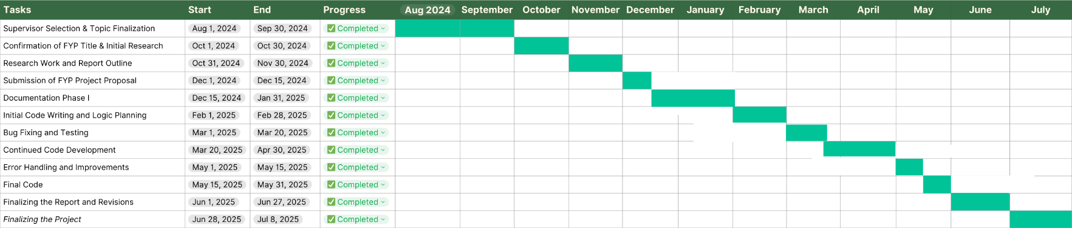

CHAPTER 2

LITERATURE REVIEW

Introduction:

In today’s digital world, managing and understanding file metadata is essential for individuals and organizations that handle large amounts of data. File metadata includes attributes like file name, size, creation date, last modified date, file type, and access permissions. These details are important for file organization, storage use, data classification, and retrieval efficiency.

The growing demand for metadata-based file analysis has led to the creation of various tools and systems. However, many of these tools struggle with usability, integration, and visualization. Traditional file managers like Windows File Explorer provide only basic viewing options. Command line tools such as ExifTool are powerful but not easy to use. Specialized programs like TreeSize Free and WizTree offer some visual aids but lack filtering or export features.

This literature review chapter aims to identify the strengths and weaknesses of existing file analysis tools, the sorting algorithms they use, and the gaps that have prompted the creation of our Project, Pro File Viewer. Our goal is to design and implement an all in one file metadata tool that is simple, efficient, and works offline, meeting the basic and advanced needs of users, especially those who are not technical.

We start by reviewing the most commonly used tools, we properly examine the algorithms they use, identify gaps in the literature and practice, and finally show how Pro File Viewer addresses these issues. This chapter lays the groundwork for our project, ensuring its relevance and usefulness in the current landscape of file management solutions.

2.2 Review Of Existing Tools & Systems

Windows File Explorer:

Windows File Explorer is the default file management app in Microsoft Windows. It offers basic functions like opening, copying, moving, renaming, and deleting files and folders. While it shows important details like file name, size, type, and last modified date, its features are limited for advanced metadata tasks. For example, it does not allow deep filtering by specific attributes such as file type, size ranges, or custom date filters. Additionally there are no built-in options for visualizing metadata through charts or exporting it in bulk formats like CSV for further analysis. This makes Windows File Explorer inadequate for users, especially professionals and researchers, who need detailed insights into file structures, particularly in deeply nested directories or large datasets.

TreeSize Free:

TreeSize Free is a popular disk-space analysis tool that helps users see the size of folders and subfolders in a clear, organized way. It allows user quickly find which directories use the most storage. The tool often shows this information through pie charts and bar graphs. Users appreciate its fast scanning and user-friendly interface. However, the free version has several limits that reduce its effectiveness for managing file metadata. It does not allow in-depth filtering based on file attributes like type, size, or modified date. It also lacks detailed metadata extraction and file previews. These limitations make TreeSize Free a useful tool for basic storage analysis, but it falls short for those who need in-depth metadata insights and data export options.

ExifTool:

ExifTool is a powerful, open-source command-line tool mainly used for reading, writing, and editing metadata in various file formats, including images, documents, and videos. Its flexibility and precision make it effective at extracting embedded metadata like creation date, author information, file version, and more. However, ExifTool functions entirely through terminal commands, which can be intimidating for users who are not technical. The lack of a graphical user interface (GUI) makes it harder for casual or inexperienced users who prefer visual interaction. It also does not offer real-time filtering, chart-based visualization, or easy export features. So ExifTool excels in technical settings, its user-friendliness is limited, making it less popular for general desktop applications focused on file metadata analysis.

WizTree:

WizTree is a fast disk space analyzer noted for its speed, which comes from directly reading the Master File Table (MFT) . It shows a treemap visualization that helps users quickly find large files and see how disk space is used across folders and subdirectories. Although WizTree is excellent at spotting storage-heavy files, its ability to handle metadata is limited. Users cannot view or filter files based on detailed metadata details like modification dates, file type, or custom file properties. It also does not let users export filtered metadata reports in structured formats like CSV, which limits its usefulness in more data analysis or reporting tasks. Therefore, while WizTree is helpful for disk management, it falls short in metadata analysis and reporting key features of tools like Pro File Viewer.

FileList:

FileList is a small, command-line utility that lets users create detailed file inventories from selected directories. It pulls essential metadata like file name, path, size, creation date, and last modification timestamp, and outputs this information in CSV or plain text format. It is particularly useful in automated workflows or scripting scenarios due to its speed and low system resource use. However, FileList lacks a GUI and does not offer options for real-time interaction, data visualization, or metadata filtering. Users must manually parse and analyze the output or import it into other tools. These drawbacks make FileList ideal for backend automation or technical documentation but not suitable for everyday metadata exploration by non-technical users.

PowerShell Scripts:

PowerShell is a task automation and configuration management framework from Microsoft, often used by system administrators to handle complex tasks like file metadata extraction. By writing custom scripts, users can access metadata attributes such as file name, type, size, timestamps, and ownership details. PowerShell also allows for conditional filtering and can export the resulting data to CSV or JSON for further analysis. However, PowerShell is code-based and does not have a graphical interface, presenting challenges for users without programming skills. It also lacks built-in visualizations or dashboards, necessitating additional tools to make sense of the results. While highly customizable, PowerShell's steep learning curve makes it less suitable for wider, user-friendly file metadata applications.

SpaceSniffer:

SpaceSniffer is a visual disk usage analyzer that uses a block-based layout (treemap) to show how storage space distributed across files and folders. It enables users to explore which files take up the most space and easily navigate directories. However, its features focused solely on visualizing disk space. It does not support metadata extraction, filtering, exporting, or searching based on file attributes. Therefore, SpaceSniffer is great for visual inspection and disk cleanup but does not have the analytical depth needed for metadata-driven applications. For projects like Pro File Viewer, where detailed access and filtering of metadata are vital, SpaceSniffer falls short.

2.3 Sorting Algorithms In File System:

Efficient file management goes beyond just listing files. It is about organizing them meaningfully based on user needs. Sorting plays a key role in making files easier to access and improving the overall user experience in file systems and applications related to metadata. The sorting algorithm used can greatly impact how responsive, accurate, and usable a tool is, especially when managing large folders and nested directories. Traditional file managers and metadata extraction tools typically use established algorithms for sorting. These include Bubble Sort, Merge Sort, Quick Sort, and the newer Tim Sort. Each of these algorithms has its own advantages and disadvantages regarding stability, complexity, and real-world performance.

Bubble Sort:

Bubble Sort is one of the simplest and oldest sorting algorithms based on comparison. It repeatedly steps through a list, compares adjacent items, and swaps them if they are out of order. This continues until no swaps are necessary, signaling that the list is sorted. Although it is easy to understand and use, Bubble Sort is inefficient with large datasets, having a time complexity. Because of this limitation, it rarely utilized in modern applications, particularly those that need fast metadata responses for many files. However, you might still find it in some basic or older systems due to its simplicity.

Merge Sort:

Merge Sort is a reliable, stable divide-and-conquer algorithm. It divides the unsorted list into halves, sorts each half, and merges the sorted back together. Merge Sort is ideal for systems that manage large amounts of data and require reliable performance, no matter how the input data is arrange. In file systems, Merge Sort is favored when it is important to maintain data integrity and sort stability. For example, when sorting files alphabetically or by date while keeping identical items in their original order, Merge Sort guarantees consistent outcomes. Its main drawback is that it requires extra space for merging, which can be an issue in a memory.

Quick Sort:

Quick Sort is a commonly used sorting algorithm in operating systems and applications because of its efficiency in average scenarios. It picks a pivot element and divides the list into two sub-lists those less than the pivot and those greater then applies the same method to those sub-lists.
Quick Sort usually performs faster than Merge Sort with unsorted datasets and has an average-case time complexity. However, it is not stable, meaning it may rearrange equal items in an unpredictable way, which can be a problem when trying to keep the order of multiple metadata attributes. Despite this, its in-place sorting feature (requiring little extra memory) makes it a favorite in performance-critical situations.

Tim Sort:

Tim Sort is a sorting algorithm created from Merge Sort and Insertion Sort. It used for real-world data that often has partially sorted sequences. Tim Sort is adaptive, stable, and efficient, with an average-case complexity. It performs even better with already partially sorted data. Its ability to identify pre-sorted data and optimize the sorting process makes it effective in situations where files might already be somewhat arranged like directories sorted by name or date. In systems that rely on metadata, Tim Sort ensures both stability and speed, making it a popular choice for graphical user interface (GUI) sorting.

Limitations of Current Tools:

Even though many file management systems use these sorting algorithms, they seldom offer advanced sorting options to users. Most tools allow only single-level sorting and sorting by one attribute at a time, such as date or size or type. Additionally, sorting is often not persistent or customizable. There is an increasing need for multi-level, dynamic, and interactive sorting in file exploration tools. For example, a user might want to sort files first by type, then by size within each type, and lastly by date modified within each group. This kind of hierarchical sorting requires both algorithmic support and thoughtful GUI design.

2.4 Identified Research Gaps

Through the examination of current tools and systems for metadata extraction and file management, several important research gaps found that limit their effectiveness and accessibility, especially for non-technical users.First, most available tools focus only on file management or metadata extraction. Very few offer a full solution that combines filtering, visualization, exporting, and interactive analysis. Users often need to use multiple tools to accomplish these tasks, which can be time-consuming and inefficient. Second, the user interfaces of many tools are outdated or too complex. Command-line applications like ExifTool and PowerShell are powerful but hard to use for those without a technical background. In contrast, GUI-based tools often lack advanced features like filtering, bulk export, or dynamic sorting. Third, most tools do not include visualization options. Visual aids like pie charts, bar graphs, or summary views can greatly enhance the user’s understanding of file structures, types, and sizes. However, these features are either missing or only available in premium versions of many applications. Fourth, existing systems usually do not offer flexible filtering options. For example, users might want to see only specific file types within a certain size range and modified during a custom date window. Very few tools allow users to combine these metadata filters dynamically in real time. Many web-based tools require internet access and are unsuitable for processing local or sensitive data. Others consume too many system resources or require installations that reduce performance on older machines. These research gaps lay the groundwork for developing Pro File Viewer, which aims to combine usability, performance, and complete metadata handling in one lightweight, standalone desktop solution.

2.5 Contribution of Pro File Viewer

In response to the gaps found in current metadata extraction and file organization tools, Pro File Viewer developed as a desktop solution. It aims to close the usability and functionality gap between existing tools and what modern users expect, whether they are technical or not. Unlike many older or scattered applications, Pro File Viewer combines essential features, such as recursive folder scanning, metadata extraction, real-time filtering, visualization, and data export, within one interface. Its lightweight design ensures it runs smoothly on low-end systems without sacrificing performance. One of the key features of this application is its modern and responsive graphical user interface (GUI). Instead of using command-line scripts or old file explorers, Pro File Viewer presents a clean and user-friendly layout. This simplifies interaction for users at all levels of experience. Key functions like selecting folders, applying filters, generating charts, and exporting data are accessible with just a few clicks. Another notable feature is its filtering module. Users can filter files by type (e.g., PDF, Word, images), size (e.g., less than 1MB, 1–10MB, greater than 10MB), and last modified date (e.g., today, this week, a custom range). These filters apply in real-time, allowing users quickly adjust their view of the dataset.

To improve user understanding, visualization tools like interactive pie charts offer quick insights into file distributions by type or size. This helps transform raw data into useful information, aiding users in making informed decisions, such as identifying which file types take up the most space or spotting unusual patterns in folder contents. Pro File Viewer also allows CSV export of filtered metadata. This is particularly beneficial for users who want to analyze or archive data externally for reporting, audits, or backups. Exported files contain metadata fields like name, type, path, size, and timestamps, providing a complete view of the file structure.The application is built to work offline and securely, ensuring that no data leaves the local system. This is especially important in sensitive environments like schools, government offices, or businesses where privacy is crucial. Finally, Pro File Viewer focuses on stability and responsiveness. It tested to manage thousands of files without lag, with efficient scanning and filtering systems. Unlike many tools that slow down with larger datasets, Pro File Viewer maintains consistent performance throughout.

CHAPTER 3

METHODOLOGY

Introduction:

To develop the Pro File Viewer desktop tool, we used structure based Incremental Software Development Model. This model allowed us to break the system into individual independent functional components that built and tested separately. It ensured that we could develop the tool in proper stages while allowing for modifications and improvements during each phase. Our main goal on user-friendliness, speed, and performance while ensuring precise metadata extraction from files.
We started the project by identifying the real-world problem: users struggled to access or filter file metadata easily. From this problem, we established key functional requirements and divided the system into seven main modules: folder selection, metadata extraction, tabular display, filter system, pie chart generation, top largest file preview, and CSV export. We used these modules in Python and tested them after completion. Once all modules were complete, we integrated them into the main system.
We also took a user-centered design approach. This meant our user interface must be simple, clean and easy to use, even for those who have not any technical knowledge. The use of ttkbootstrap provided a modern and consistent interface across all modules. We tested each function with folders containing different file types, sizes, and structures to check the speed and accuracy.

Data Required & Controlled By The System:

Metadata as Primary Data Source:

Pro File Viewer work on file metadata, which is the data linked to each file and managed by the operating system. This metadata includes important details like the file name, extension (type) and file size, full directory path, and the last modified date. Our application uses this metadata to help users better understand their file storage and structure without needing to inspect each file manually. The data is collect when a user selects a folder. The application scans the selected folder and all subfolders and files inside it. This is essential for real-world use, as users often organize files across multiple folder levels.

Data Handling and Security:

The application designed for user privacy and data safety in mind. It does not read, open, modify, delete, or move any files. It only retrieves file properties using safe system calls through Python’s built-in modules. This ensures that users can depend on the application with any type of folder, including those containing sensitive or personal data. All functionality performed in read-only mode, and the application does not send any data online. It work on the local machine without requiring any hardware and internet. Once data is visible in table, it can filtered, sorted, visualized based on user preferences.

Purpose of Data Usage:

The stored and collected metadata serves several purposes within the system, this ensures that the collected data not only informs the user but also enables deeper analysis and smarter file organization.

- Filters are applied based on file type, size, and date.
- A pie chart shows distribution by file type.
- The five largest files are identifying for preview and selection.
- Filtered data can exported as a CSV file for documentation.

Solution Implementation Environment:

Programming Language & Framework:

The system develop in Python, a popular and flexible programming language ideal for file manipulation and GUI-based applications. We used Tkinter module due to its easy integration with Python. To improve the appearance and user experience, we utilized ttkbootstrap, a modern theming library offering pre-styled, visually appealing components.

File Handling & System Libraries:

The application uses built-in Python libraries to interact with the file system:
- OS library use to scan directories and access file paths.
- Stat library use to extract file attributes like size and timestamps.
- Date-time library use to convert Unix timestamps into readable formats.
These libraries enable efficient and secure interaction with the file system, ensuring the application can smoothly handle large sets of files.

Visualization & Export Features:

In this application uses graphically representation for file type distribution, we used the most useful library matplotlib library to create a pie chart. This visualization help users to understand the variety and ratio of file types in the scanned folder. The chart updates dynamically after a scan .For exporting for desired filtered results, we used Python’s csv module. This feature allows users to save the filtered table view into a .csv file, which can open in Microsoft Excel for further review, sharing, or documentation.

Development & Testing:

Development took place on a Windows 10 system using Jupyter-Notebook. We tested all application features using local folders with various file types (e.g., .pdf, .docx, .xlsx, .png, .exe). Testing scenarios included scanning folders with hundreds of files, nested subfolders, and files with long names or large sizes. The application does not require any internet connection and it is platform-independent. It can run directly as a .py file as an executable .exe file using tools like PyInstaller for easier deployment.

Functions Provided By The System:

The Pro File Viewer application provides the following core functionalities:
- Folder Selection and Scanning: The user selects any folder, and the system scans it recursively to include files from all folder and subfolders.
- Metadata Extraction: For each file, metadata such as file name, size, extension, path, and last modified date is collected.
- Tabular Display: All extracted data is display in a scrollable, sortable table within the table.
- Filtering System: Users can apply filters by file type (e.g., .pdf, .docx), file size range, or last modified date.
- Visualization: A pie chart illustrates the percentage of each file type present in the folder.
- Top Files Preview: The five largest files in the scanned folder visible separately for quick review and selection.
- Export to CSV: Filtered results can exported into a .csv file for record-keeping, sharing, or further analysis.

Use Case Diagram:



Export to CSV
View Pie Chart | Filtered Results

Show All Files | Filtered Results

Display Filtered Results | Display Filtered Results

Apply Advanced Filter
Extract Metadata

Scan Files

Browse Folder

CHAPTER 4
- REQUIREMENT SPECIFICATION & DESIGN

Proposed System & Required Specification:

Proposed System:

Pro File Viewer is user-friendly desktop application for analyzing and managing file metadata. It allows users to scan a selected folder and its subfolders, automatically gathering metadata such as file name, size, type, and modification date. This information appears in a clear, sortable table and readable format. Users can easily apply different filters like file type, size, and date to narrow down the desired results. The application also provides charts for visual representation and options to export data to CSV files. It is lightweight and easy to use, works offline, and suitable for both technical and non-technical users.

Requirement Specification:

Functional Requirements:

- Users can browse and select any folders and sub folders.
- The system will scan the all selected folder and subfolders recursively.
- Metadata such as name, type, size, and modified date extracted through different filters.
- Display all results in a table format with sorting features.
- Users can filter files by size, type, and modification date.
- Pie chart visualization shows all the types of file included in selected folder.
- Preview of the top five largest file inside the folder.
- User easily Export their desired filtered results to CSV.

Non-Functional Requirements:

- The system must respond quickly and efficiently while handling large folders.
- Application can be run offline without needing any hardware and internet access.
- The tool must support various file types and large datasets.
- The UI must be simple and accessible to all type of users.
- It can be compatible across platforms through .py or executable .exe.

Logical Design:

Flowchart Diagram:

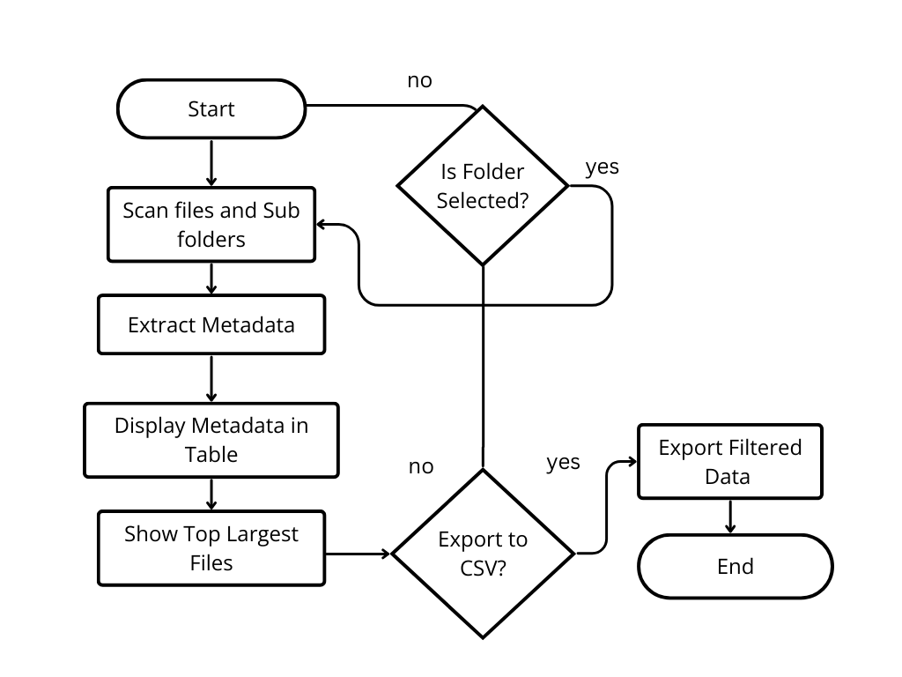

UML Diagram:

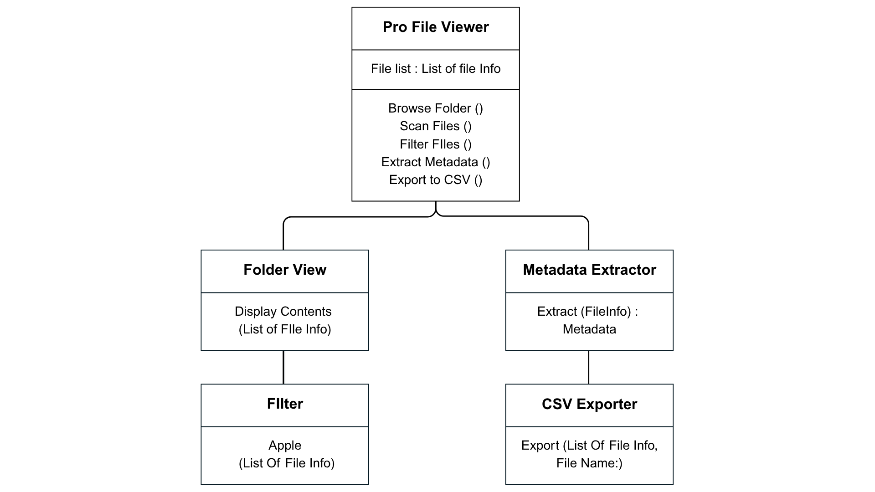

Data Flow Diagram:

DFD Level 1 Diagram:
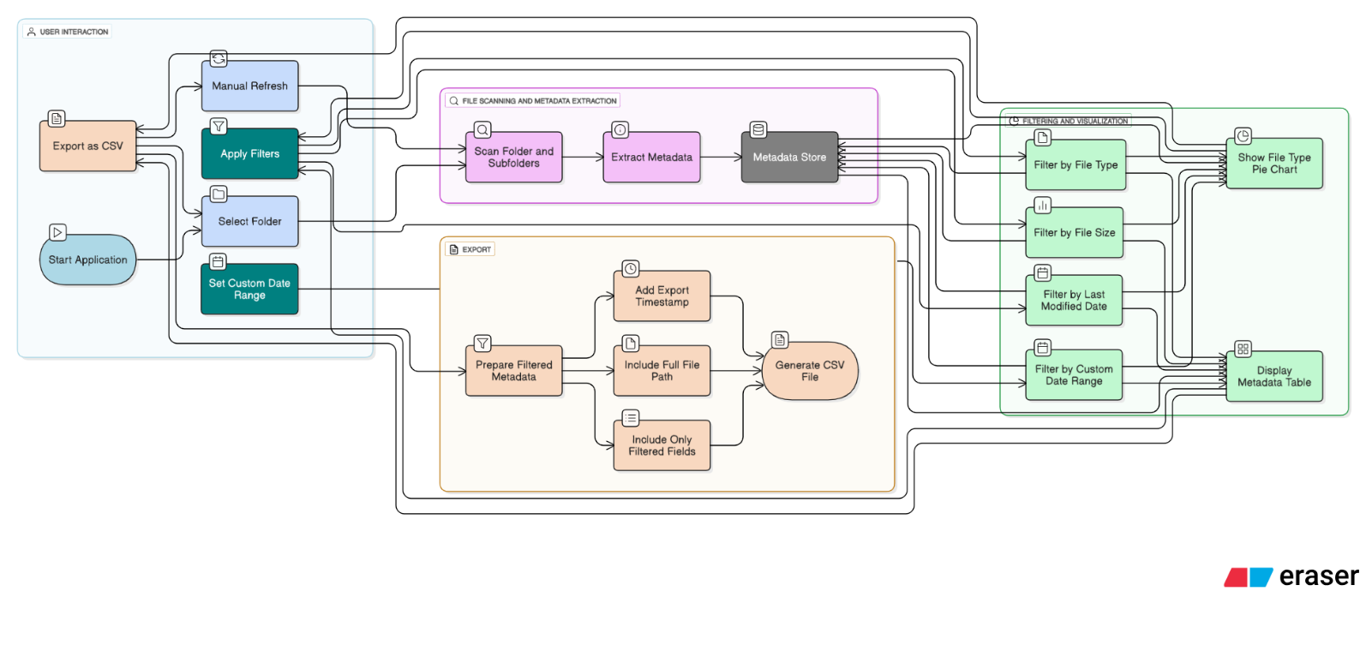

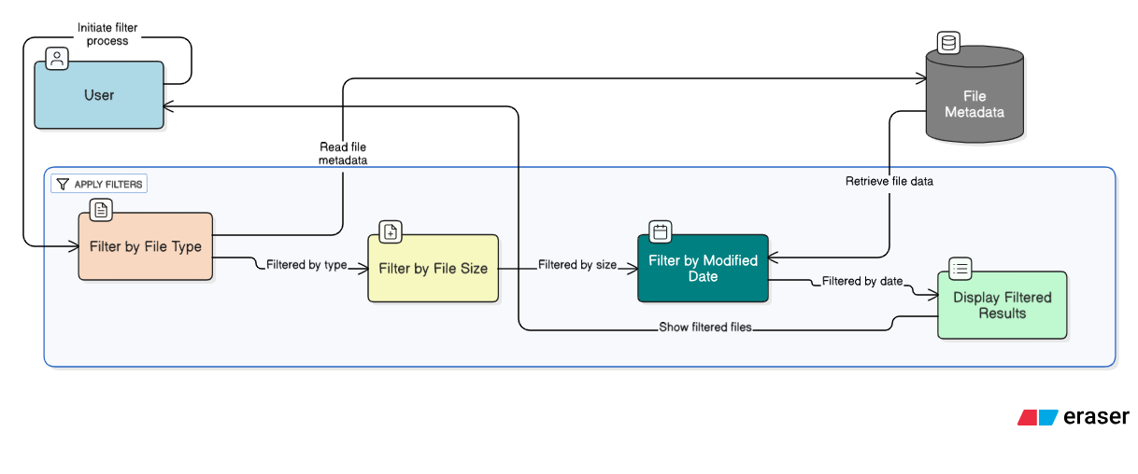
Apply Filter

Metadata Extraction Process (DFD)
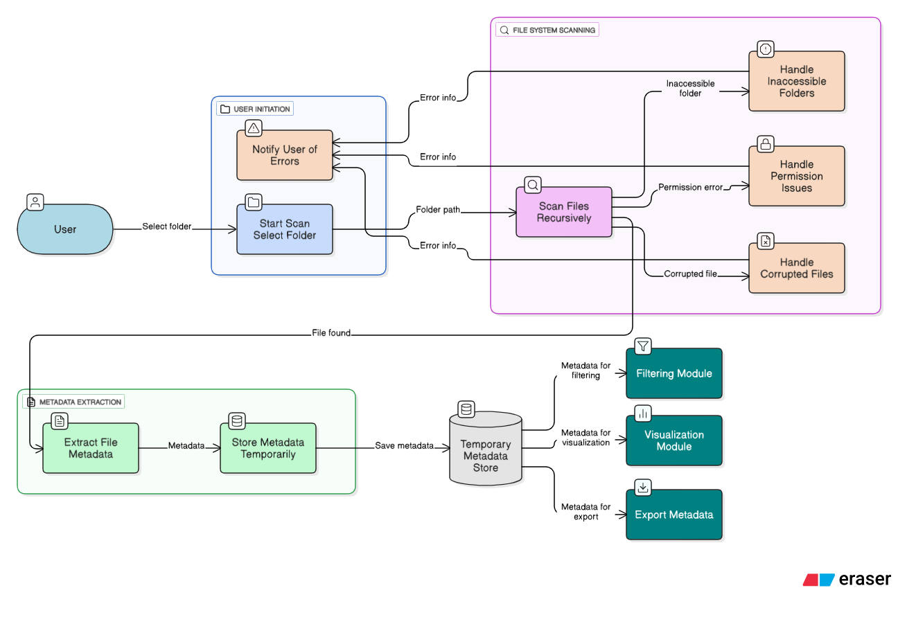

Software Development Lifecycle:

Agile Model:

For the development of Pro File Viewer, we used the Agile SDLC model. This model helped us break the project into small phases, called sprints. It allowed for continuous development, testing, and improvement. We developed and tested each module of the system separately after completion. These modules included folder selection, metadata extraction, file filtering, and CSV export. Agile allowed our team to stay flexible. We could respond to feedback and address issues early. We completed each feature step-by-step. We also added improvements like pie charts and top file previews partway through the process and tested the application regularly. By using Agile, we delivered a complete and polished project on time. This approach led to better performance and an improved user experience.

4.4. Interface / GUI:

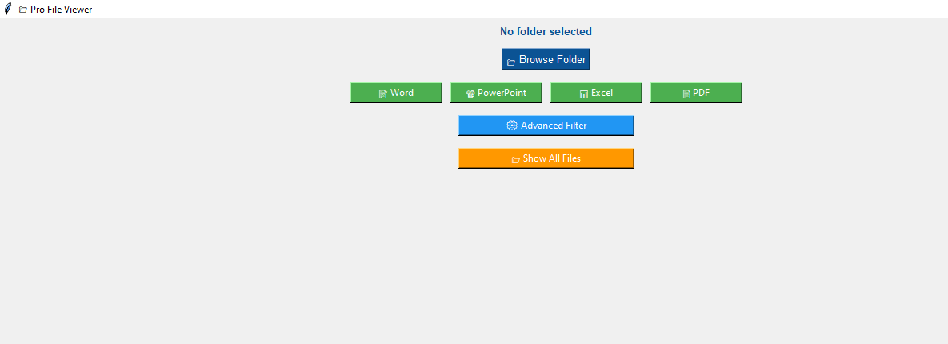
System Layout:

Home Page Layout:
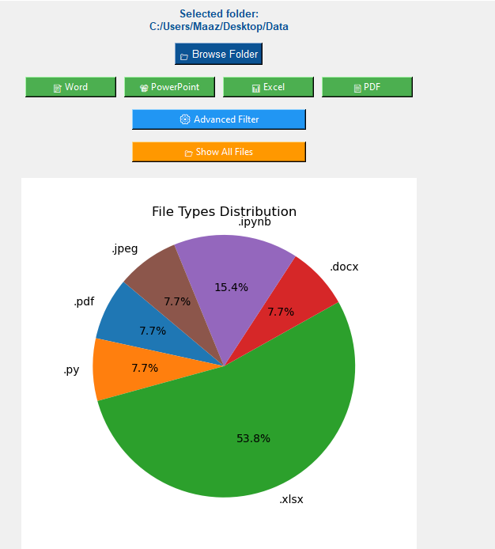
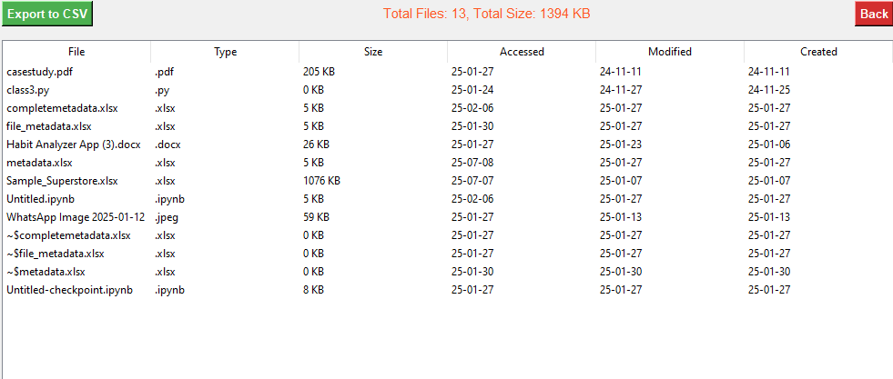

Category:

After scanning the selected folder, Pro File Viewer automatically finds and groups files by their types. The system sorts files into categories like documents, spreadsheets, images, and executables. These categories shown in a pie chart, helping users quickly see how many files are in each category and how much each category contributes to the folder.

The chart updates in real time when filters are applied. This feature provides users with an easy and visual way to examine storage patterns and file distribution.



Top Four Different File Extensions:

The different file section in Pro File Viewer shows a unique type of the files in the chosen folder, including subfolders. This feature helps users quickly spot the files that take up the most storage space. After the system scans a folder, it sorts all the files by size from largest to smallest. The different files displayed in a separate panel on the interface.



Export To CSV Layout:

This section shows the part of the interface where users can export the filtered file metadata as a CSV file. This feature is useful for reporting, backup, or further analysis. The export button is located at the bottom of the interface and becomes active once data is loaded.

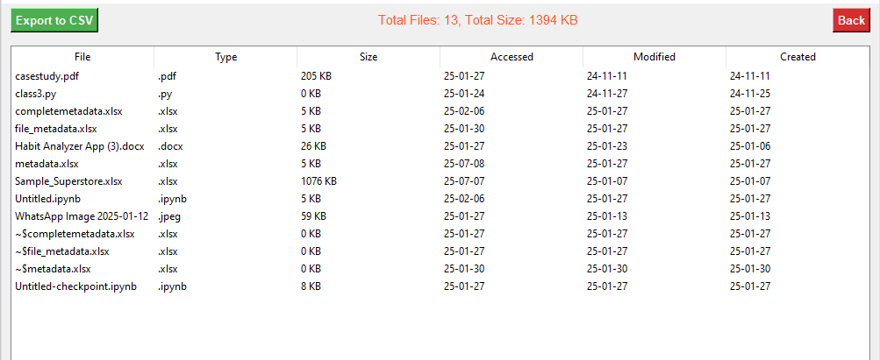

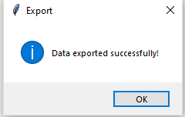

Filter Panel Layout:

The filter panel lets users narrow the file list by choosing file type, file size range, or last modified date. This section helps users focus on relevant files and updates both the table and chart in real time.
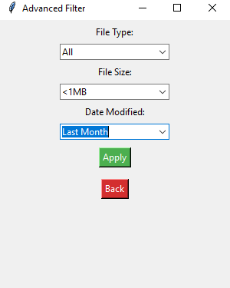

Error Message Layout:

Pro File Viewer also includes error handling for common situations like selecting an empty folder, unsupported files, or paths that deny permission. The interface shows clear and user-friendly error messages to help users troubleshoot easily.

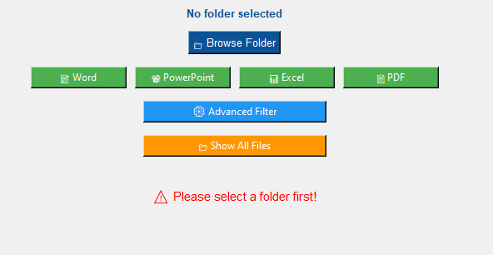

CHAPTER 5
- SYSTEM IMPLEMENTATION

Overview:

This chapter explains how we developed the Pro File Viewer desktop application using Python and ttkbootstrap. It discusses the tools, technologies, development process, and features we created. We used Agile approach, finishing various functionalities in short sprints and improving them based on testing and feedback.

Algorithm Used:

This section describes the main algorithms and logic used in Pro File Viewer. These algorithms are essential for the system, allowing it to scan folders, extract metadata, apply filters, visualize file types, and export data efficiently.

Folder Scanning Algorithm:

In this application system uses Python’s built-in os.walk() method to scan all files and subfolders within the selected directory. For each file found, the path is stored and sent for metadata extraction. This approach ensures that no file is over-looked, even in deeply nested structures.

- It Handles thousands of files quickly
- It Supports folders with complex subfolder trees
- It Ignores inaccessible or hidden system files using try-except handling

Metadata Extraction Algorithm:

After scanning, the system collects each file’s metadata using the os.stat() method.The extracted fields include:
- File Name
- File Extension / Type
- File Size
- Last Modified Date
- File Path

File Filtering Logic:

Filters are applying to the extracted metadata using custom Python logic, these logics updates the data shown in the table and makes it easy for users to isolate specific files.

- File Type Filter: Matches extensions like .pdf, .docx, etc.
- Size Filter: Compares file size to user-defined minimum and maximum values.
- Date Filter: Filters files based on the modification date range.

Pie Chart Generation:

The system counts the number of files for each file type using a frequency dictionary. Then, it uses matplotlib.pyplot.pie() to create a real-time pie chart showing file type distribution. This chart updates every time the folder filters are applied.

Steps:
1. Count file types using a loop.
2. Store the count in a dictionary.
3. Pass the data to matplotlib to create the pie chart.

Top Largest Files Algorithm:

The system sorts all files based on their size. Custom logic selects the five largest files and displays them in a special preview area of the UI. This helps users quickly identify which files are taking up the most space.

CSV Export Logic:

The filtered results are showing to a .csv file using Python’s csv module then file includes metadata such as file name, size, type, and path for each filtered entry. This function is useful for reporting, documentation, or audits.

Tools / Technology Used:

To develop the Pro File Viewer desktop base application, we chose technologies that are reliable, efficient, lightweight, and suitable for building a tool. This section explains the main technologies, frameworks, and tools used for both the frontend and backend, along with the development environment and deployment method.

Frontend Section

The frontend of Pro File Viewer create using Tkinter, Python’s built-in GUI library, along with the ttkbootstrap extension. Tkinter enabled us to create the graphical user interface with windows, buttons, labels, entry fields, tables, and dialog boxes. It supports all essential GUI components and integrates well with backend logic. To improve the visual appeal and usability of the interface, we used ttkbootstrap, a common library that offers modern UI designs similar to Bootstrap. It helped us create a more intuitive, responsive, and clean user interface with colored buttons, styled tables, and readable fonts, all of which contribute to a better user experience. Together, Tkinter and ttkbootstrap formed the foundation of the application’s user interface, allowing us to deliver a simple and attractive layout for non-technical users.

Backend Section

The backend of the system was developed entirely in Python 3, using standard and third-party libraries. The backend ensures efficient file handling, real-time filtering, and error handling, keeping the application stable and responsive during use. Main logic of the application, such as folder scanning, file metadata extraction, data filtering, visualization, and CSV export, is handle in the backend using the following Python modules:
- os module: Used for navigating folders and subfolders recursively with os.walk().
- stat module: Accesses file-specific information such as file size, permissions, and timestamps.
- datetime module: Converts raw timestamp data into a human-readable format for sorting and filtering.
- csv module: Exports the filtered data to .csv files, enabling further use in Excel or reporting.
- matplotlib: Generates the pie chart that visually shows the distribution of file types.

Programming Language
The entire application develop using Python 3. We selected Python due to its ease of use, rich standard libraries, and suitability for rapidly developing desktop applications. It also offers strong support for file system operations, error handling, and modular design, making it ideal for this type of utility tool.

Development Environment
The initial development and testing took place in Jupyter Notebook, which made it easier to write, debug, and test code in sections. Jupyter’s cell-based interface divided in step-by-step validation of the core logic, especially during the file scanning and filtering phases. The project was developed and tested on a system running Windows 10, which is commonly used in educational and office environments. All core functionalities were verified to work correctly on this platform.

Deployment Tool
For deployment, we used PyInstaller to convert the final Python script into an executable (.exe) file. This allowed the application to run on systems without Python installed, making it portable and user-friendly. The .exe version includes all dependencies bundled together, so the user only needs to run the file without any additional setup.

Visualization Tool
To visualize the distribution of file types, we used Matplotlib, a widely used Python library for data visualization. It generates a real-time pie chart after folder scanning, giving the user a quick overview of how files are distributed based on type (e.g., PDF, DOCX, PNG, etc.). The chart updates dynamically when filters are applied.

Code Section:

Import Libraries and Initialization:

import tkinter as tk
from tkinter import filedialog, ttk
from tkinter import messagebox
from Metadata import meta
from PiaChart import show_filetype_pie_in_frame
import csv

selected_folder = ""

Browse Folder Function:

def browse_folder():
global selected_folder
selected_folder = filedialog.askdirectory()
if selected_folder:
show_filetype_pie_in_frame(selected_folder, chart_frame)

Open Filter Window:

def open_filter_window():
if selected_folder:
import AdvanceFilter
AdvanceFilter.open_filter_screen(selected_folder)
else:
messagebox.showwarning("Warning", "Please select a folder first.")

Show All Files and Metadata:

def show_all_files():
if selected_folder:
data = meta(selected_folder)

result_window = tk.Toplevel(root)
result_window.title("Metadata Result")

columns = ("File", "Type", "Size", "Accessed", "Modified", "Created")
tree = ttk.Treeview(result_window, columns=columns, show="headings")
for col in columns:
tree.heading(col, text=col)
tree.column(col, width=150)
tree.pack(padx=10, pady=10, fill=tk.BOTH, expand=True)

for row in data:
tree.insert("", tk.END, values=row)

def export_to_csv():
file_path = filedialog.asksaveasfilename(defaultextension=".csv", filetypes=[("CSV files", "*.csv")])
if file_path:
with open(file_path, 'w', newline='', encoding='utf-8') as file:
writer = csv.writer(file)
writer.writerow(["File", "Type", "Size", "Accessed", "Modified", "Created"])
for row_id in tree.get_children():
row = tree.item(row_id)['values']
writer.writerow(row)
messagebox.showinfo("Success", "Data exported to CSV successfully.")

export_button = tk.Button(result_window, text="Export to CSV", command=export_to_csv)
export_button.pack(pady=5)

else:
messagebox.showwarning("Warning", "Please select a folder first.")

GUI Layout & Main Window:

root = tk.Tk()
root.title("Pro File Viewer")
root.geometry("700x600")

frame = tk.Frame(root)
frame.pack(pady=10)

browse_button = tk.Button(frame, text="Browse Folder", command=browse_folder)
browse_button.grid(row=0, column=0, padx=5)

word_button = tk.Button(frame, text="Word", command=lambda: filter_and_display("word"))
word_button.grid(row=0, column=1, padx=5)

excel_button = tk.Button(frame, text="Excel", command=lambda: filter_and_display("excel"))
excel_button.grid(row=0, column=2, padx=5)

pdf_button = tk.Button(frame, text="PDF", command=lambda: filter_and_display("pdf"))
pdf_button.grid(row=0, column=3, padx=5)

ppt_button = tk.Button(frame, text="PowerPoint", command=lambda: filter_and_display("ppt"))
ppt_button.grid(row=0, column=4, padx=5)

filter_button = tk.Button(frame, text="Advance Filter", command=open_filter_window)
filter_button.grid(row=0, column=5, padx=5)

all_button = tk.Button(frame, text="Show All Files", command=show_all_files)
all_button.grid(row=0, column=6, padx=5)

chart_frame = tk.Frame(root)
chart_frame.pack(fill=tk.BOTH, expand=True)

root.mainloop()

End of Code Section

CHAPTER 6

- TESTING AUTOMATION TESTING

Testing Tools:

Testing is a most important step of the software development life cycle (SDLC). It ensures that the entire system works as expected under all defined conditions. For the development and validation of Pro File Viewer, we used a hybrid testing approach that combined both automated and manual methods. This section details the tools we used to test various components of the project, their purpose, and how they helped verify the system's performance and stability of the overall project.

Python unittest Framework:

We tested the core backend features of our Pro File Viewer tool, such as file metadata extraction, recursive folder scanning, file type filtering, size filtering, and CSV export logic, using Python's built-in unittest module. We chose this testing tool because it works well with Python, requires no extra installation, and offers a structured way to automate test case execution. With unittest, we created multiple test functions to check if individual components were producing accurate results. This included testing different file types, verifying edge cases (like unsupported or unreadable files), and confirming that filter outputs matched the given criteria.

Manual Testing for GUI:

The Pro File Viewer features a graphical user interface developed with Tkinter and ttkbootstrap, we performed manual testing on all user interaction components. These include folder selection, input fields, dropdown filters, the pie chart view, preview of the top five largest files, and export options. Manual testing ensured that the graphical interface performed consistently and met usability expectations for both technical and non-technical users. We manually ran several scenarios to verify:

- The system's responsiveness to user input.
- The correct visual updates of the metadata table and charts.
- The ability to handle unexpected inputs (for example, no folder selected or an empty directory).

Simulated Folder Environments:

For our project we do both manual and automated testing for over all functions, we prepared various mock folders containing real and dummy files with extensions such as .pdf, .docx, .xlsx, .jpg, .exe, and .txt. These folders included subfolders with multiple levels and a range of file sizes, from a few KBs to several MBs, to simulate realistic file environments. These functions allowed us to:

- Test performance on large-scale directories.
- Validate the logic for recursive folder traversal.
- Observe how the application behaves with a high number of files.

Tool Selection:

We chose the unittest module for its simplicity, built-in availability with Python, and its efficiency in running logic tests. It helped us find bugs early and ensure consistent output across different datasets. We opted for manual testing on UI components because Python's GUI frameworks are not easily automatable using standard testing tools like Selenium which focus more on web and mobile applications.

Additional Modules:

In addition to unittest, we used the following tools to support the testing process:

- Jupyter Notebook: Used for code prototyping, debugging, and executing logic in smaller segments.
- PyInstaller: Assisted in creating .exe files to test the tool on systems without Python installed.

Testing Methods:

To make sure that the Pro File Viewer desktop application was reliable, efficient, and easy to use for all users, we applied several well-known testing methods. We carefully chose these methods based on the structure and functionality of our project. This project includes backend logic for file scanning, filtering, and metadata extraction, as well as a graphical user interface built with Tkinter. Each method helped us assess the system's performance under various conditions, find bugs, and improve usability.
Black Box Testing | We used black box testing to evaluate the application’s functionality from the user’s point of view, without looking at the internal code. We tested the system by performing tasks like selecting folders, scanning files, applying filters, and exporting metadata to CSV. The main goal was to see if the output matched the expected results based on user actions. For example, after selecting a folder with multiple file types, we expected the data table to show accurate metadata, the pie chart to update accordingly, and the export feature to create a well-formatted CSV file. This method helped us confirm that all features worked correctly and provided proper feedback, even when the input was invalid or incomplete.
White Box Testing | White box testing allowed us to examine the internal workings of the system. Since we developed the project in Python, we used the unittest module to test individual functions in the backend. We looked at loops, conditions, and function outputs in the logic that handled recursive folder scanning with os.walk(), metadata extraction with os.stat(), and filter logic based on file size, type, and modified date. These tests helped us find and fix logical errors early on and ensure that the system behaved correctly under all conditions, even with large folders or unusual file types
Integration Testing | Integration testing helped us verify that the different modules of the application worked together .We tested whether selecting a folder would trigger scanning, which would then send data to be displayed in the table and chart. We also checked whether applying filters would update the table, chart, and preview panel simultaneously, and whether filtered results correctly exported to a CSV file. This method confirmed that the components were well-connected and worked as a unified system

Test Cases:
Test Case ID | TC-01 | Test Case Description | Select valid folder
Screen / Form | Folder Selection | User | Tester
S. No | Prerequisites
1 | Application must be launched

Test Case 01

Test Scenario | User selects a valid folder for scanning
Step # | Step Details | Expected Result
1. Launch app
2. Click "Browse"
3. Select folder with files4. Click "Scan"

Files from folder are displayed in the
metadata table

Execution Details
Tester Name | M. Siddiqui | Iteration | 1st
Date Tested | 9-07-2025 | Overall Outcome Of Test Case | Pass
Steps By Steps Result
Step # | Actual Result
 | As Expected
Test Case ID | TC-02 | Test Case Description | Scan folder with nested subfolders
Screen / Form | Folder Scanning | User | End User
S. No | Prerequisites
1 | Valid folder must be selected

Test Case 02

Test Scenario | Folder contains multiple levels of subfolders
Step # | Step Details | Expected Result
1. Select folder
2. Click "Scan"

 |  | Files from all subfolders displayed in the table

Execution Details
Tester Name | M. Siddiqui | Iteration | 1st
Date Tested | 9-07-2025 | Overall Outcome Of Test Case | Pass
Steps By Steps Result
Step # | Actual Result
 | As Expected
Test Case ID | TC-03 | Test Case Description | Handle empty folder
Screen / Form | Folder Scanning | User | End User
S. No | Prerequisites
1 | Empty folder must be selected

Test Case 03
Test Scenario | User scans a folder that has no file
Step # | Step Details | Expected Result
1. Select empty folder
2. Click "Scan"

 |  | Message displayed: "No files found"

Execution Details
Tester Name | M. Siddiqui | Iteration | 1st
Date Tested | 9-07-2025 | Overall Outcome Of Test Case | Pass
Steps By Steps Result
Step # | Actual Result
 | As Expected
Test Case ID | TC-04 | Test Case Description | Extract metadata correctly
Screen / Form | Metadata Extraction | User | End User
S. No | Prerequisites
1 | Folders with selected files

Test Case 04
Test Scenario | Metadata like name, type, size, date extracted
Step # | Step Details | Expected Result
1. Scan folder
2. View metadata table

 |  | Accurate metadata displayed for all files

Execution Details
Tester Name | M. Siddiqui | Iteration | 1st
Date Tested | 9-07-2025 | Overall Outcome Of Test Case | Pass
Steps By Steps Result
Step # | Actual Result
 | As Expected
Test Case ID | TC-05 | Test Case Description | Filtered by file type
Screen / Form | Filtering module | User | End User
S. No | Prerequisites
1 | Folders must be scanned

Test Case 05
Test Scenario | User applies type filter (e.g., PDF)
Step # | Step Details | Expected Result
 | 1. Apply file type filter
 |  | Only files of selected type shown in the table

Execution Details
Tester Name | M. Siddiqui | Iteration | 1st
Date Tested | 9-07-2025 | Overall Outcome Of Test Case | Pass
Steps By Steps Result
Step # | Actual Result
 | As Expected

Test Case ID | TC-06 | Test Case Description | Filtered by modified date
Screen / Form | Filtering module | User | End User
S. No | Prerequisites
1 | Folders must be scanned

Test Case 06
Test Scenario | User selects date filter
Step # | Step Details | Expected Result
 | 1. Set date range
 |  | Only files modified within selected date range shown

Execution Details
Tester Name | M. Siddiqui | Iteration | 1st
Date Tested | 9-07-2025 | Overall Outcome Of Test Case | Pass
Steps By Steps Result
Step # | Actual Result
 | As Expected

Test Case ID | TC-07 | Test Case Description | Filtered by file size
Screen / Form | Filtering module | User | End User
S. No | Prerequisites
1 | Folders must be scanned

Test Case 07
Test Scenario | User filters files larger than 1MB
Step # | Step Details | Expected Result
 | 1. Apply file size filter
 |  | Only files >1MB are displayed

Execution Details
Tester Name | M. Siddiqui | Iteration | 1st
Date Tested | 9-07-2025 | Overall Outcome Of Test Case | Pass
Steps By Steps Result
Step # | Actual Result
 | As Expected

Test Case ID | TC-08 | Test Case Description | No results for unmatched filter
Screen / Form | Filtering module | User | End User
S. No | Prerequisites
1 | Folders must be scanned

Test Case 08
Test Scenario | Filters applied return no matching files
Step # | Step Details | Expected Result
 | 1. Apply invalid combo filters
 |  | Empty table shown

Execution Details
Tester Name | M. Maaz | Iteration | 1st
Date Tested | 10-07-2025 | Overall Outcome Of Test Case | Pass
Steps By Steps Result
Step # | Actual Result
 | As Expected
Test Case ID | TC-09 | Test Case Description | Export filtered results to CSV
Screen / Form | CSV export | User | End User
S. No | Prerequisites
1 | Folders must be scanned

Test Case 09
Test Scenario | User exports full table without filter
Step # | Step Details | Expected Result
 | 1. Click "Export to CSV"
 |  | CSV contains all scanned file data

Execution Details
Tester Name | M. Maaz | Iteration | 1st
Date Tested | 10-07-2025 | Overall Outcome Of Test Case | Pass
Steps By Steps Result
Step # | Actual Result
 | As Expected
Test Case ID | TC-10 | Test Case Description | Pie chart displays file type distribution
Screen / Form | Visualization | User | End User
S. No | Prerequisites
1 | Folders must be scanned

Test Case 10
Test Scenario | Pie chart should visualize type percentage
Step # | Step Details | Expected Result
 | 1. View chart after scanning
 |  | Chart accurately shows distribution

Execution Details
Tester Name | M. Maaz | Iteration | 1st
Date Tested | 10-07-2025 | Overall Outcome Of Test Case | Pass
Steps By Steps Result
Step # | Actual Result
 | As Expected
Test Case ID | TC-11 | Test Case Description | Replace old data on re-scanning
Screen / Form | Folder Scanning | User | End User
S. No | Prerequisites
1 | One Folders must be already scanned

Test Case 11
Test Scenario | User selects a new folder, expects updated data
Step # | Step Details | Expected Result
1. Scan folder A
2. Scan folder B

 |  | Old data should be replaced with new data in table

Execution Details
Tester Name | M. Maaz | Iteration | 2nd
Date Tested | 10-07-2025 | Overall Outcome Of Test Case | Fail (1st),  Pass (2nd)
Steps By Steps Result
Step # | Actual Result
 | Previously retained old data, now fixed

CHAPTER 7
- CONCLUSION & FUTURE WORK

Conclusion:

The Final Year Project titled Pro File Viewer aimed to tackle a common issue for many computer users: managing and reviewing large sets of files stored in different folders and subfolders. We developed this desktop application using Python and the ttkbootstrap framework. We develop user-friendly tool that allows users to scan folders, extract and view file metadata, apply smart filters, and export results for further use. This makes it easier to identify file types, sizes, and modified dates without needing any technical knowledge. With adding features like pie chart visualizations, it not only provides accurate information but also improves the overall user experience. We thoroughly tested the system, and it performs well with various file structures and dataset sizes. Pro File Viewer is a lightweight, offline application that does not need any internet connection, making it accessible for students, teachers, office workers, and IT staff. It prioritizes data privacy by only reading metadata without changing or modifying any user files. Our testing showed that the system was stable, responsive, and easy to use.

During development, we faced challenges such as accuracy of metadata, performance issues during scans of large folders, and responsiveness of the GUI. However, with teamwork, debugging, and regular testing, we resolved all known issues and improved the application's stability. This process helped us strengthen our software engineering skills and apply what we learned in the classroom to a real-world problem.

In overall conclusion, the project met its goals by delivering a tool that connects technical file data with usability for non-technical users. It shows our ability to design, implement, test, and document a real-world software solution from scratch. Feedback from peers and test users has been positive, and we believe this tool provides genuine value in the area of file management.

Future Work:

The current version of Pro File Viewer meets its intended goals, but several key features and improvements could make it easier to use and improve performance. These improvements aim to expand the application's capabilities and give users more control.

Multi-Folder Scanning:

Allow users to scan multiple folders at the same time. This will help analyze files from different locations in one or two steps and improve the efficiency of bulk metadata collection.

Search and Filter Enhancement:

In future work we add a search bar to help locate files by keywords or names. Improve the filtering system to allow for combined filters, advanced size ranges, or date ranges, giving users stronger search options.

Report Generation Using Differ Formats:

Add the ability to export reports in PDF or DOCX formats. These reports could include pie charts, summaries, and file tables, which would make the tool suitable for professional reporting and academic documentation.

Cloud Storage Support:

Enable users to scan cloud-based folders from platforms like Google Drive or Dropbox. This will broaden the application’s use in modern settings where users store data online.

Drag and Drop User Personalization:

Add drag-and-drop functionality for folders and let users save theme settings, filters, and preferences. This will significantly improve the user experience and make the app more interactive. Future work also includes compiling the application into cross-platform executables for Windows, Linux, and macOS using packaging tools like PyInstaller. With ongoing feedback and future improvements, Pro File Viewer can evolve into a professional-grade desktop utility for modern file management. This development plan shows our commitment to making the tool more flexible, accessible, and useful in different environments.

- REFRENCES:
- https://github.com/israel-dryer/ttkbootstrap
- https://github.com/python/cpython/blob/main/Lib/csv.py
- https://realpython.com/python-os-module/#file-attributes
- https://matplotlib.org/stable/gallery/pie_and_polar_charts/pie_features.html
- https://github.com/python/cpython/blob/main/Lib/csv.py
- https://ttkbootstrap.readthedocs.io/en/latest/

